NAME :B THARUN KUMAR REDDY

REG NO:192111508

COURSE CODE:CSA1288

COURSE NAME:COMPUTER ARCHITECTURE

FACULTY NAME:DR G.MARY VALANTINA

DATE:8/10/2022

Write an assembly language program to find factorial of n in the given number.

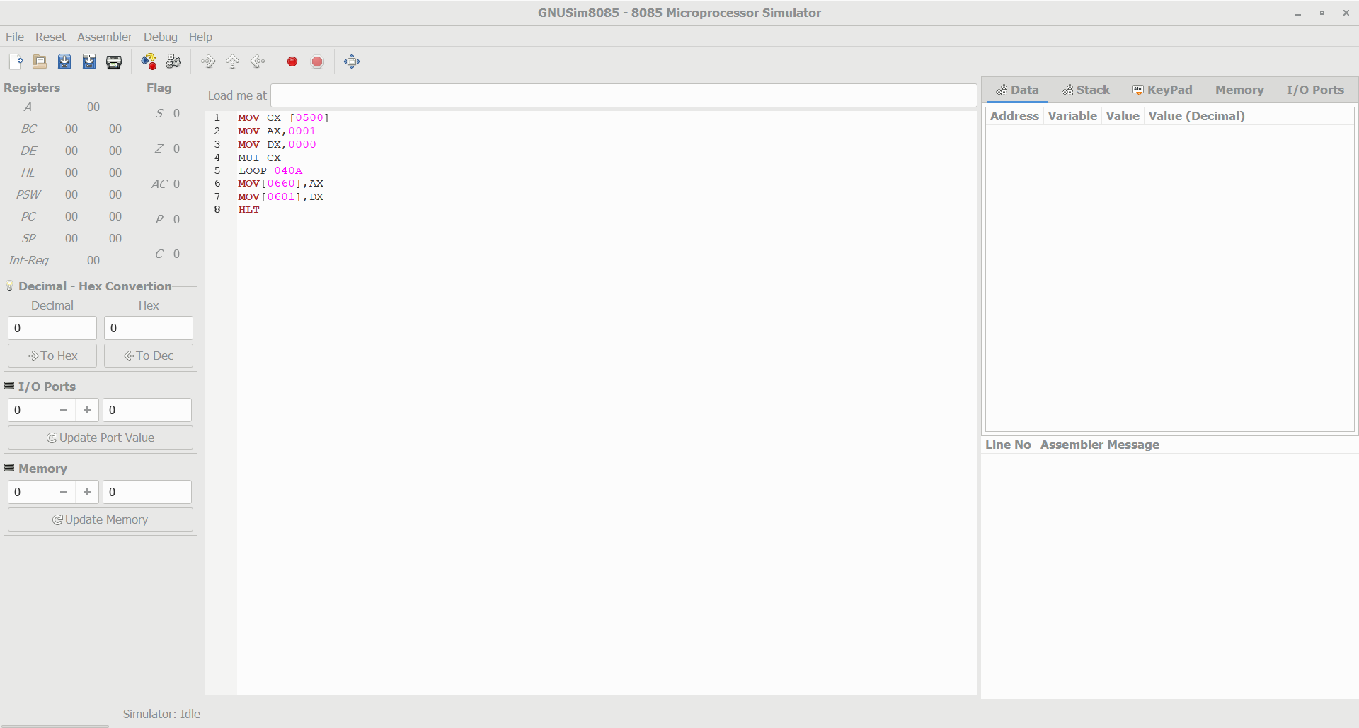

1. Write a program to convert Binary to Hexadecimal number to number using any high level language.

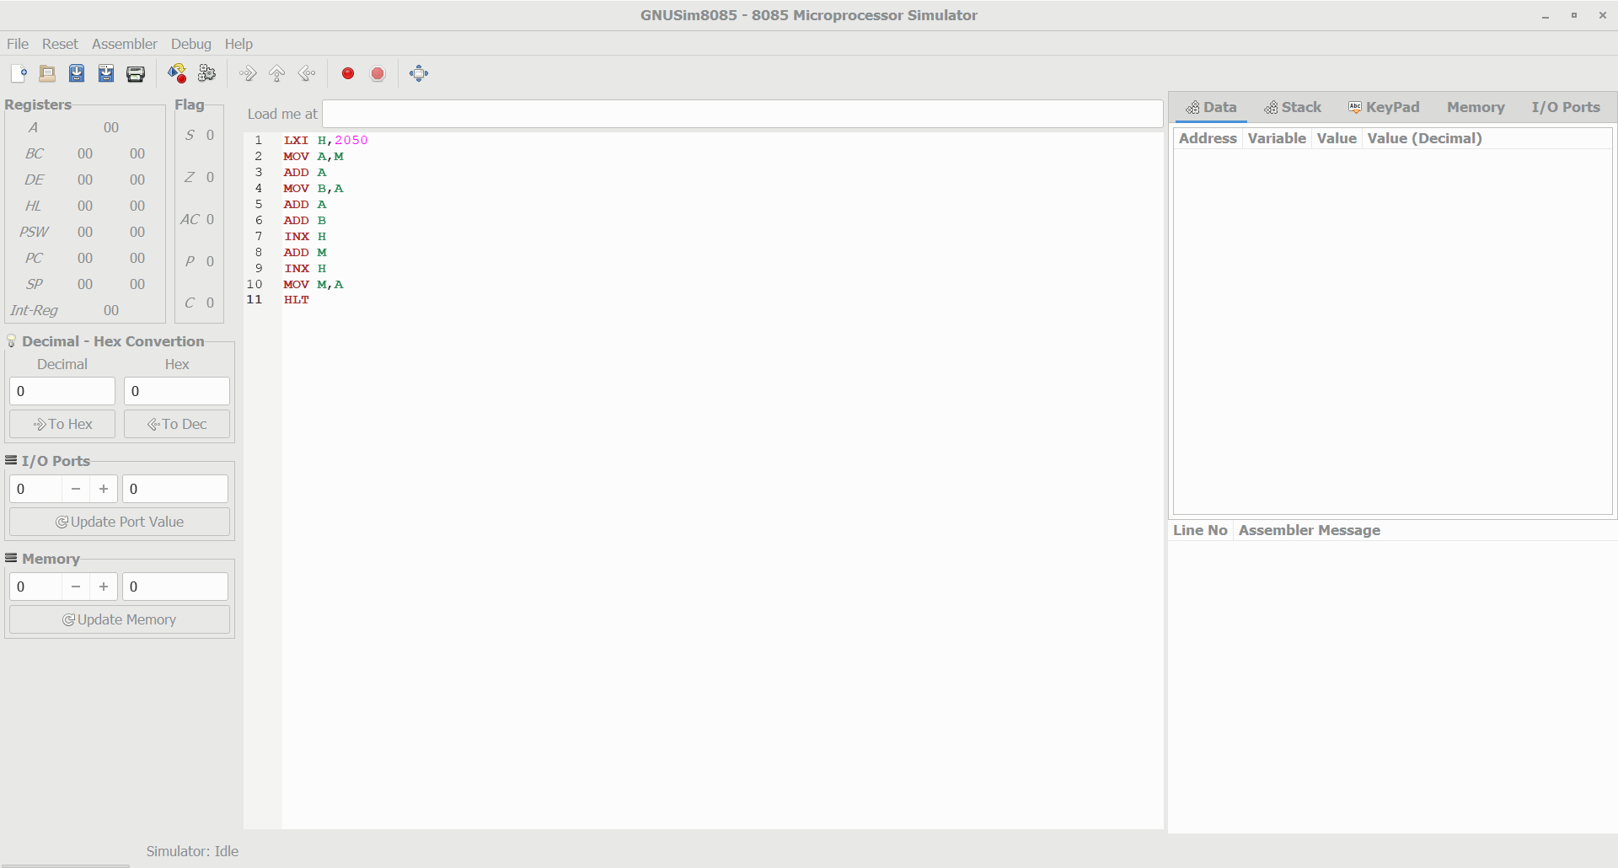

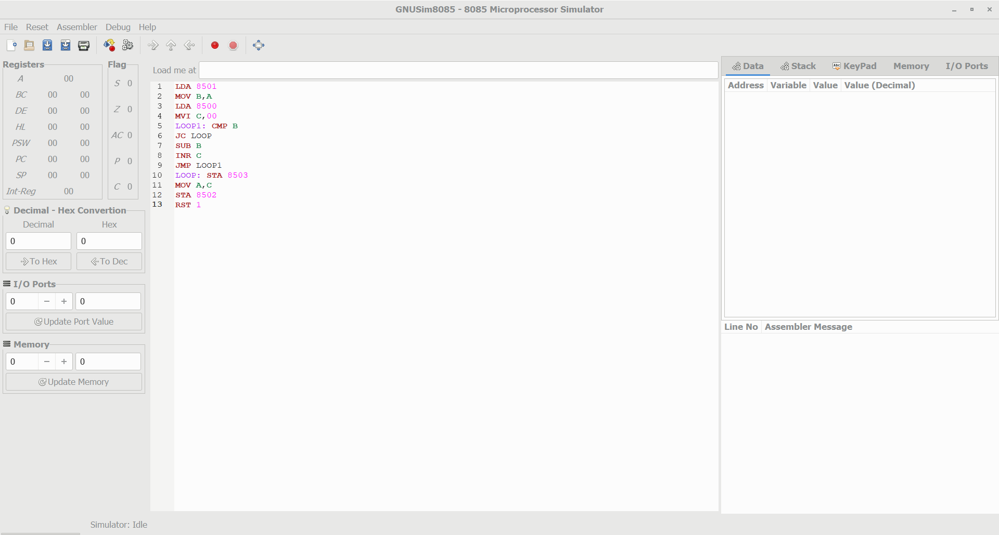

1. Write an assembly language program to find the given 8-bit number is Prime or not using 8085 processor.

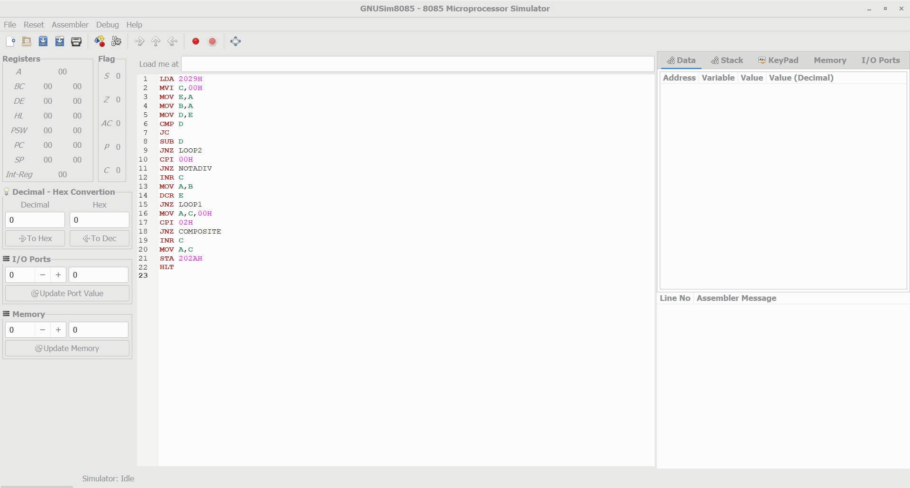

add

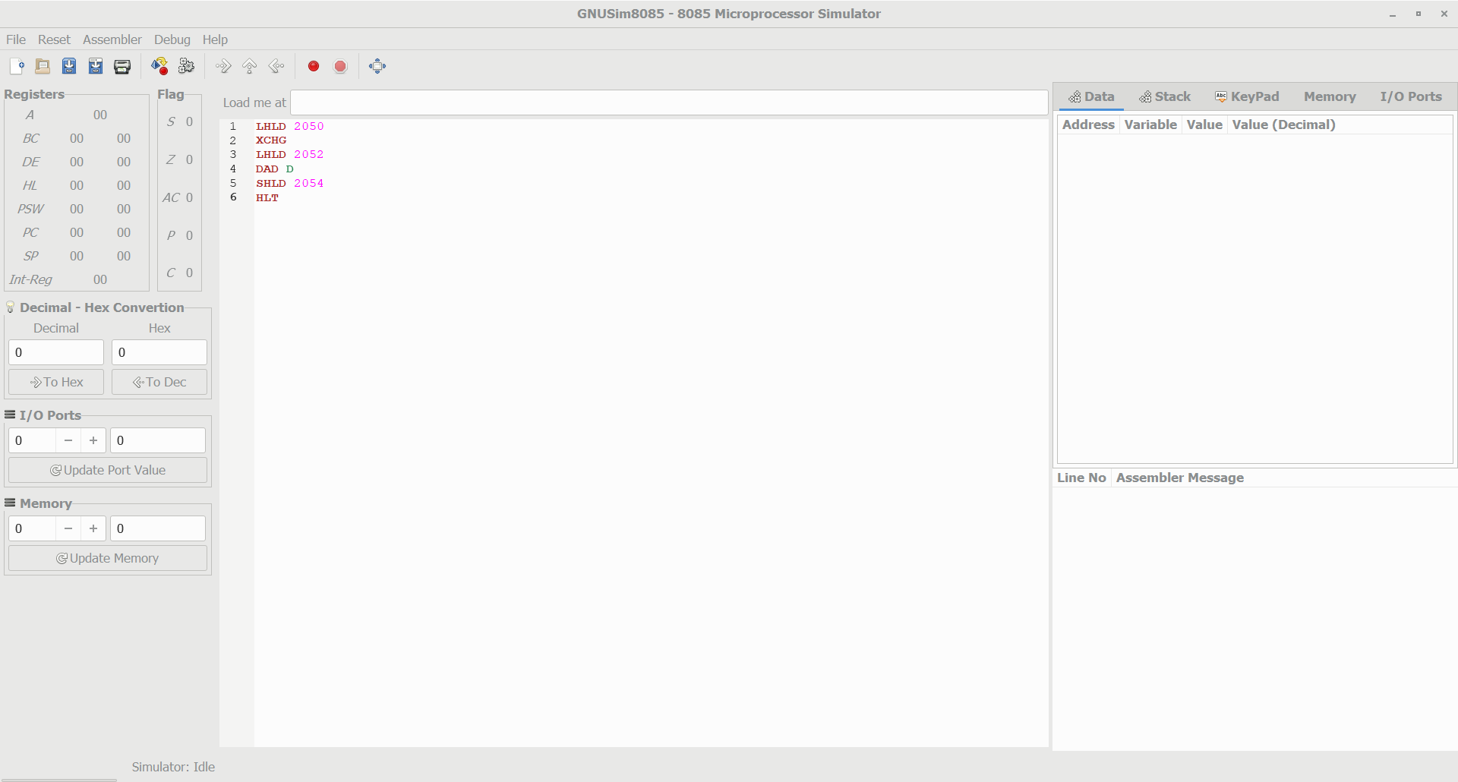

Sub

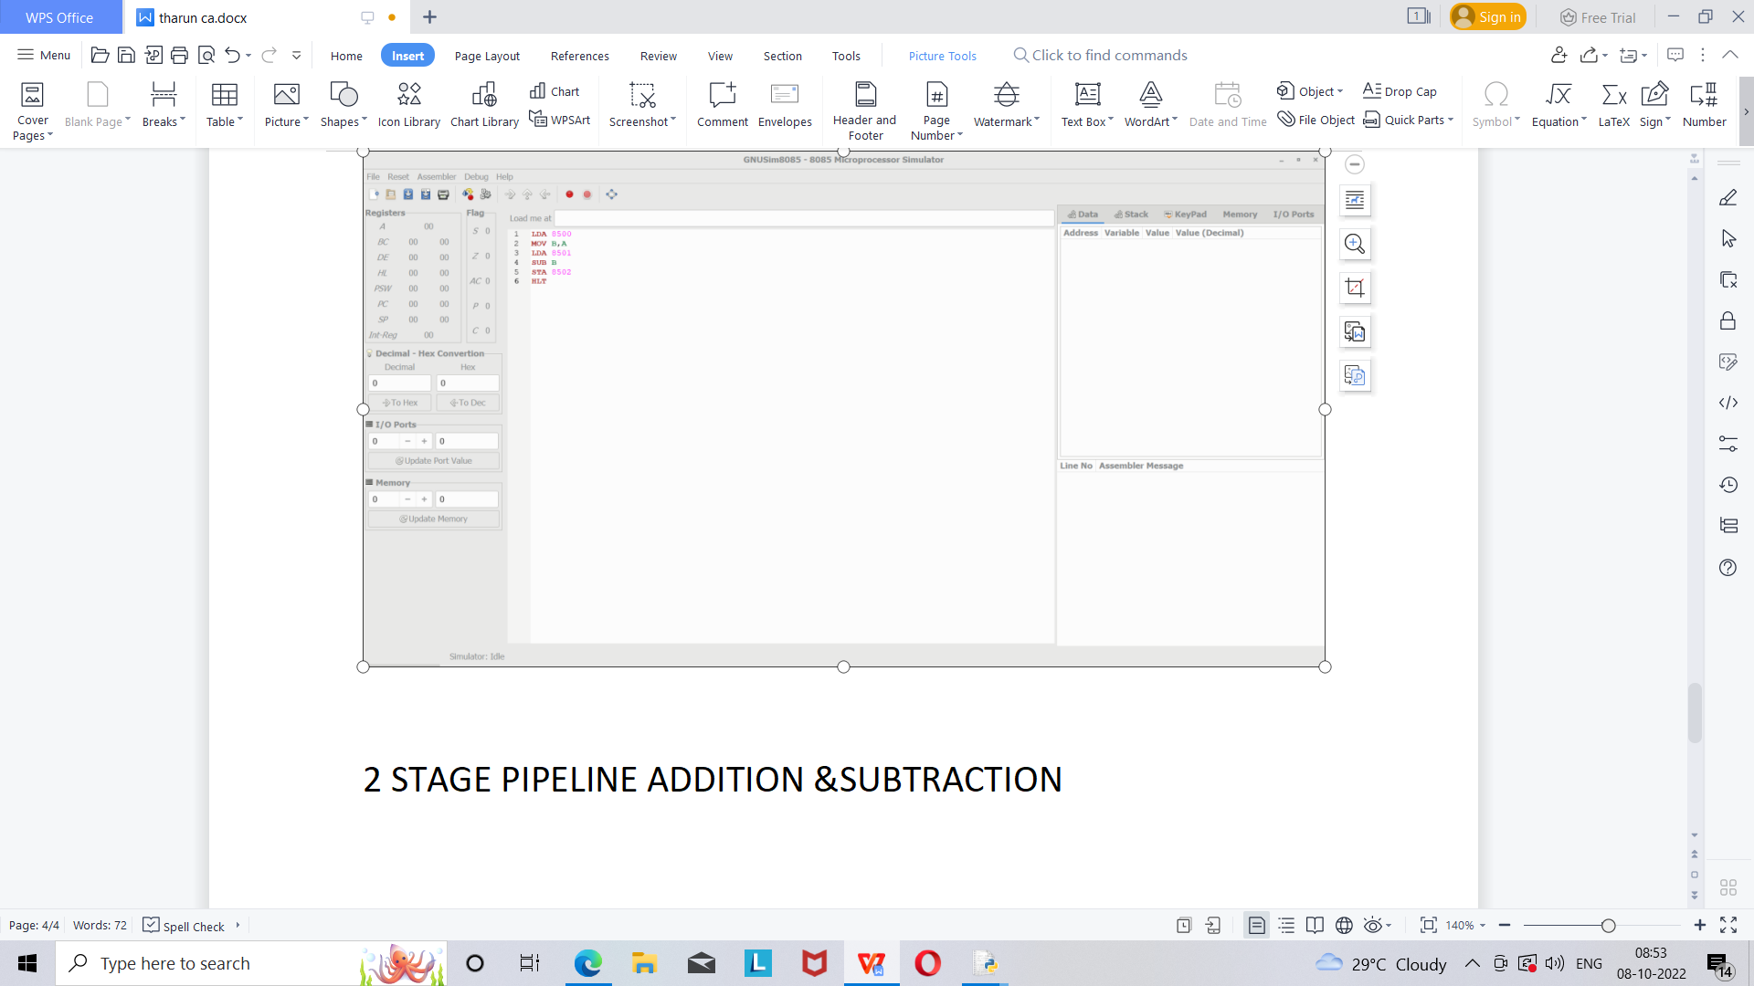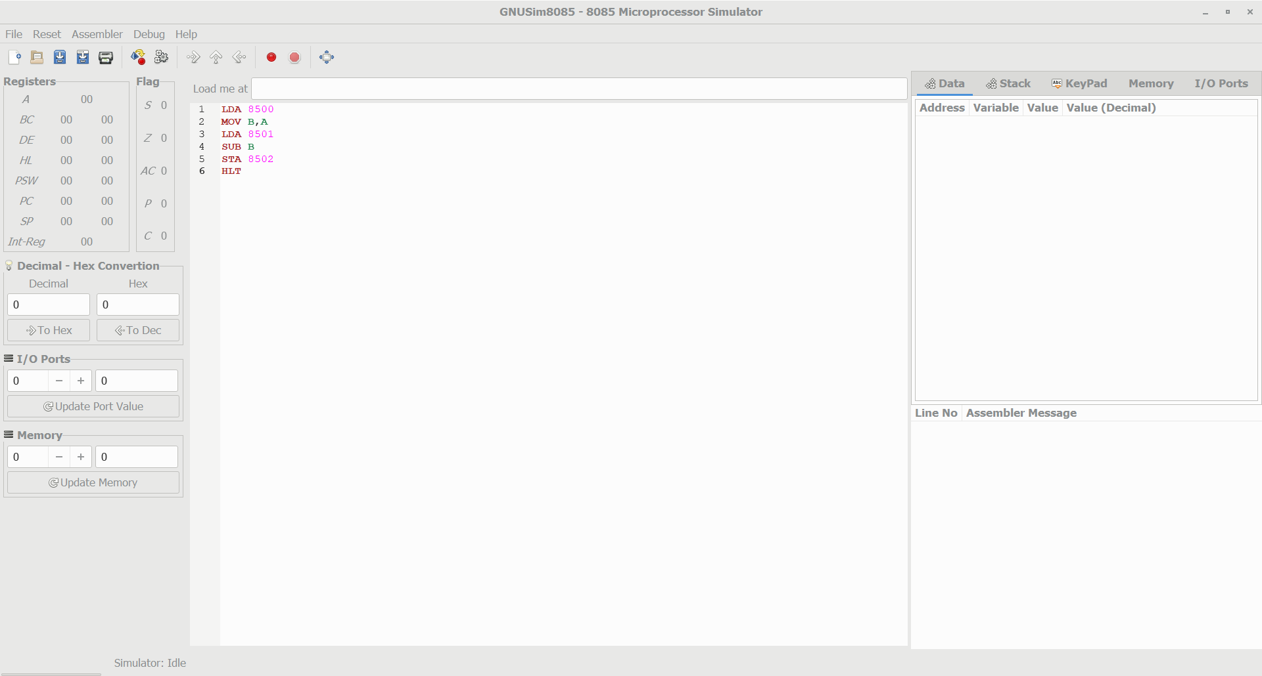

2 STAGE PIPELINE ADDITION &SUBTRACTION